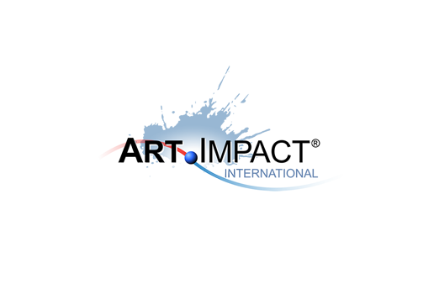
ARTIST INTERVIEW QUESTIONS
- What jobs have you done other than being an artist?
- Why art? Why do you do what you do?
- What’s the most challenging aspect of being an artist?
- How has your practice changed overtime? How did you get here?
- How would you describe yourself?
- Is the artistic life lonely? If so, what do you do to counteract it?
- What do you dislike about the art world?
- What do you like about your work? / What are you most proud of?
- What role does the artist have in society?
- Should art be funded? What role does arts funding have?
- What makes you angry? What research to you do?
- What superpower would you have and why?
- Name something you love, and why.
- Name something you don’t love, and why.
- What is your dream project?
- Professionally, what’s your goal?
- Name three artists you’d like to be compared to or have inspired you.
- Favorite or most inspirational place?
- What memorable responses have you had to your work?
- What’s the best piece of advice you’ve been given?

